**Group/Team no: G24/T13**

**BUILD YOUR OWN PORTFOLIO SITE**

**Submitted by Group/Team No: G24**

**Kartik Sharma 2210990489**

**Kartik Verma 2210990490**

**Kartik Bhardwaj 2210990487**

**Kartik Grover 2210990488**

**in partial fulfillment for the award of the degree of**

**BACHELEOR OF ENGINEERING**

***in***

COMPUTER SCIENCE & ENGINEERING



**CHITKARA UNIVERSITY**

**CHANDIGARH-PATIALA NATIONAL HIGHWAY RAJPURA (PATIALA) PUNJAB-140401 (INDIA)**

**May 2023**

**Front End Engineering-I 22CS004**

|  |  |  |  |  |
| --- | --- | --- | --- | --- |
|  | **Group/Team no: G24/T13**  **Index** | | |  |
|  | Sr. no | Section | Page no |  |
|  | 1. | **Introduction** | **3** |  |
|  | 2. | **Problem Statement** | **4** |  |
|  | 3. | **Technical Details** | **5** |  |
|  | 4. | **Key Features** | **6** |  |
|  | 5. | **Project Highlights** | **7** |  |
|  |  |  |  |  |
|  | 6. | **Advantages** | **9** |  |
|  | 7. | **Result** | **10** |  |
|  | 8. | **Conclusion** | **11** |  |

## Introduction

A portfolio website is an online platform that showcases an individual's or a company's professional work, achievements, skills, and expertise. In this digital age, having a well-designed and thoughtfully curated portfolio

website is essential for professionals in various fields . The purpose of this presentation is to highlight the

importance of a portfolio website, its benefits, and provide key insights on how to create an effective and impactful online portfolio.

The portfolio builder website also aims to offer a wide range of customization options to suit the

individual preferences and branding of each user. This includes options for choosing color schemes, fonts, layouts,

and overall themes that

with the user's personal or professional style. By offering a high degree of customization, the website allows users to

create portfolios that reflect their unique identity and make a memorable impression on potential employers,

collaborators.  
  
 Moreover, a portfolio builder website often provides additional features and functionalities to enhance the

presentation and impact of the portfolios. This may include integration with social media platforms, allowing users

to showcase their work to a wider audience. The website may also provide analytics tools that offer insights into

the portfolio's performance, such as the number of views or engagement metrics, helping users track the impact

of their portfolio and make informed decisions to improve its effectiveness.

Overall, the goal of a portfolio builder website is to provide a powerful tool for individuals to showcase their work

and advance their career or business goals.



## Problem Statement

## Establishing Your Online Presence

## Control Over Your Brand

## Showcasing Your Work

## Customization and Flexibility

## Increased Credibility and Professionalism

## Accessibility and Availability

## Networking and Career Advancement

## 

## Technical Details

1. Web Hosting: Selecting a reliable web hosting service that will host our website files and make it accessible

on the internet. Consider factors like server reliability, uptime guarantees, storage space, bandwidth, and

customer support.

2. Content Management System (CMS): Choose a CMS platform that suits your needs and technical proficiency.

A CMS simplifies website management and allows you to easily update content, add new projects, and customize

the website's design.

3. Design and Layout: Developing an aesthetically pleasing and user-friendly design for our portfolio

website. Considering the color scheme, typography, and overall layout to create a visually appealing

experience. Responsive design is crucial to ensure your website looks and functions well across different devices

and screen sizes.

4. Front-End Development: Using HTML, CSS, and JavaScript to build the front-end of our portfolio website

HTML defines the structure of your web pages, CSS styles the elements and controls their appearance, and

JavaScript adds interactivity and functionality

## Key Features

* + Captivating Homepage: A visually appealing and engaging homepage that captures the attention of visitors and provides a snapshot of your work.
  + About Me/About Us: A section that provides background information about yourself or your company, including your experience, qualifications, and unique selling points.
  + Portfolio/Creative Work: The heart of your portfolio website, showcasing your best projects, work samples, case studies, or creative endeavors, organized in a clear and intuitive manner.
  + Testimonials: Featuring testimonials from satisfied clients or colleagues can build trust and credibility reinforcing your skills and expertise.
  + Contact Information: Make it easy for visitors to get in touch with you by including your contact

information, such as email address, phone number, or social media links.

# Project Highlights

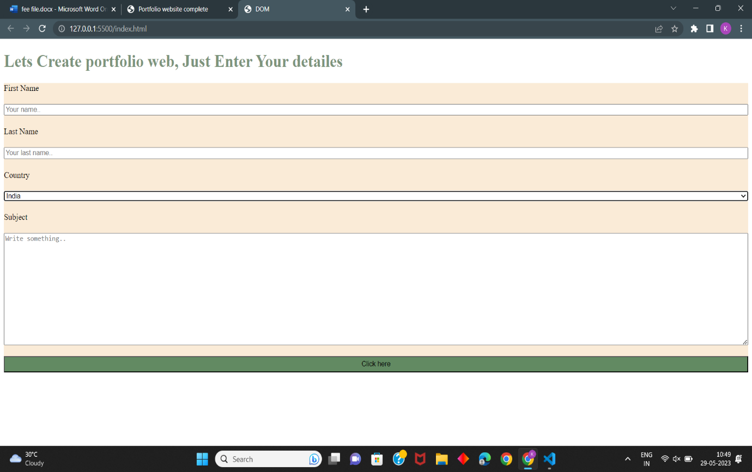

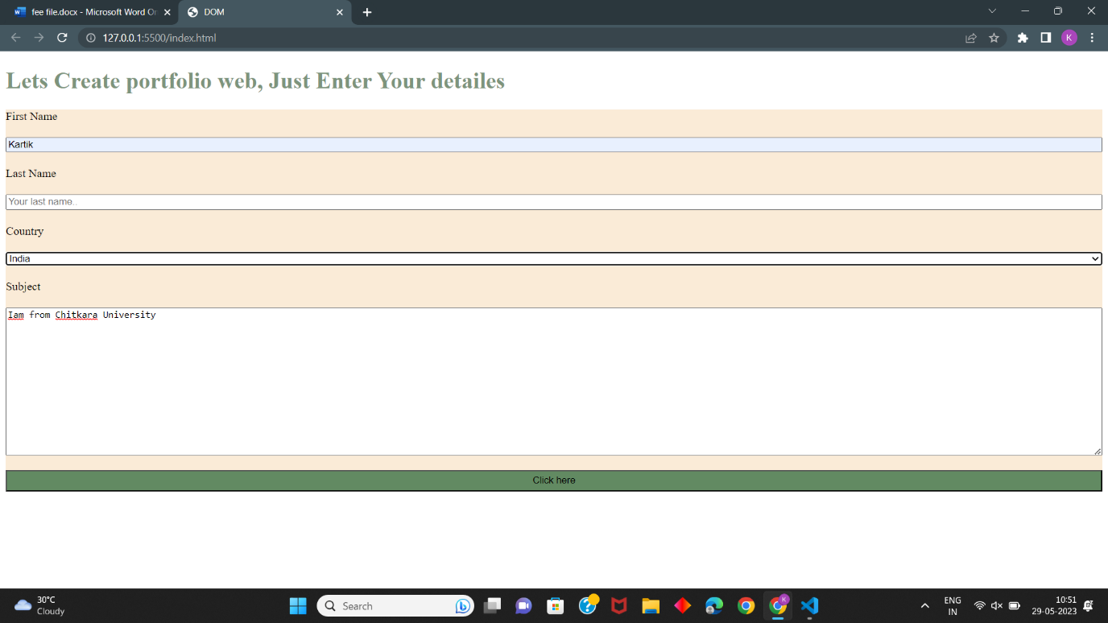

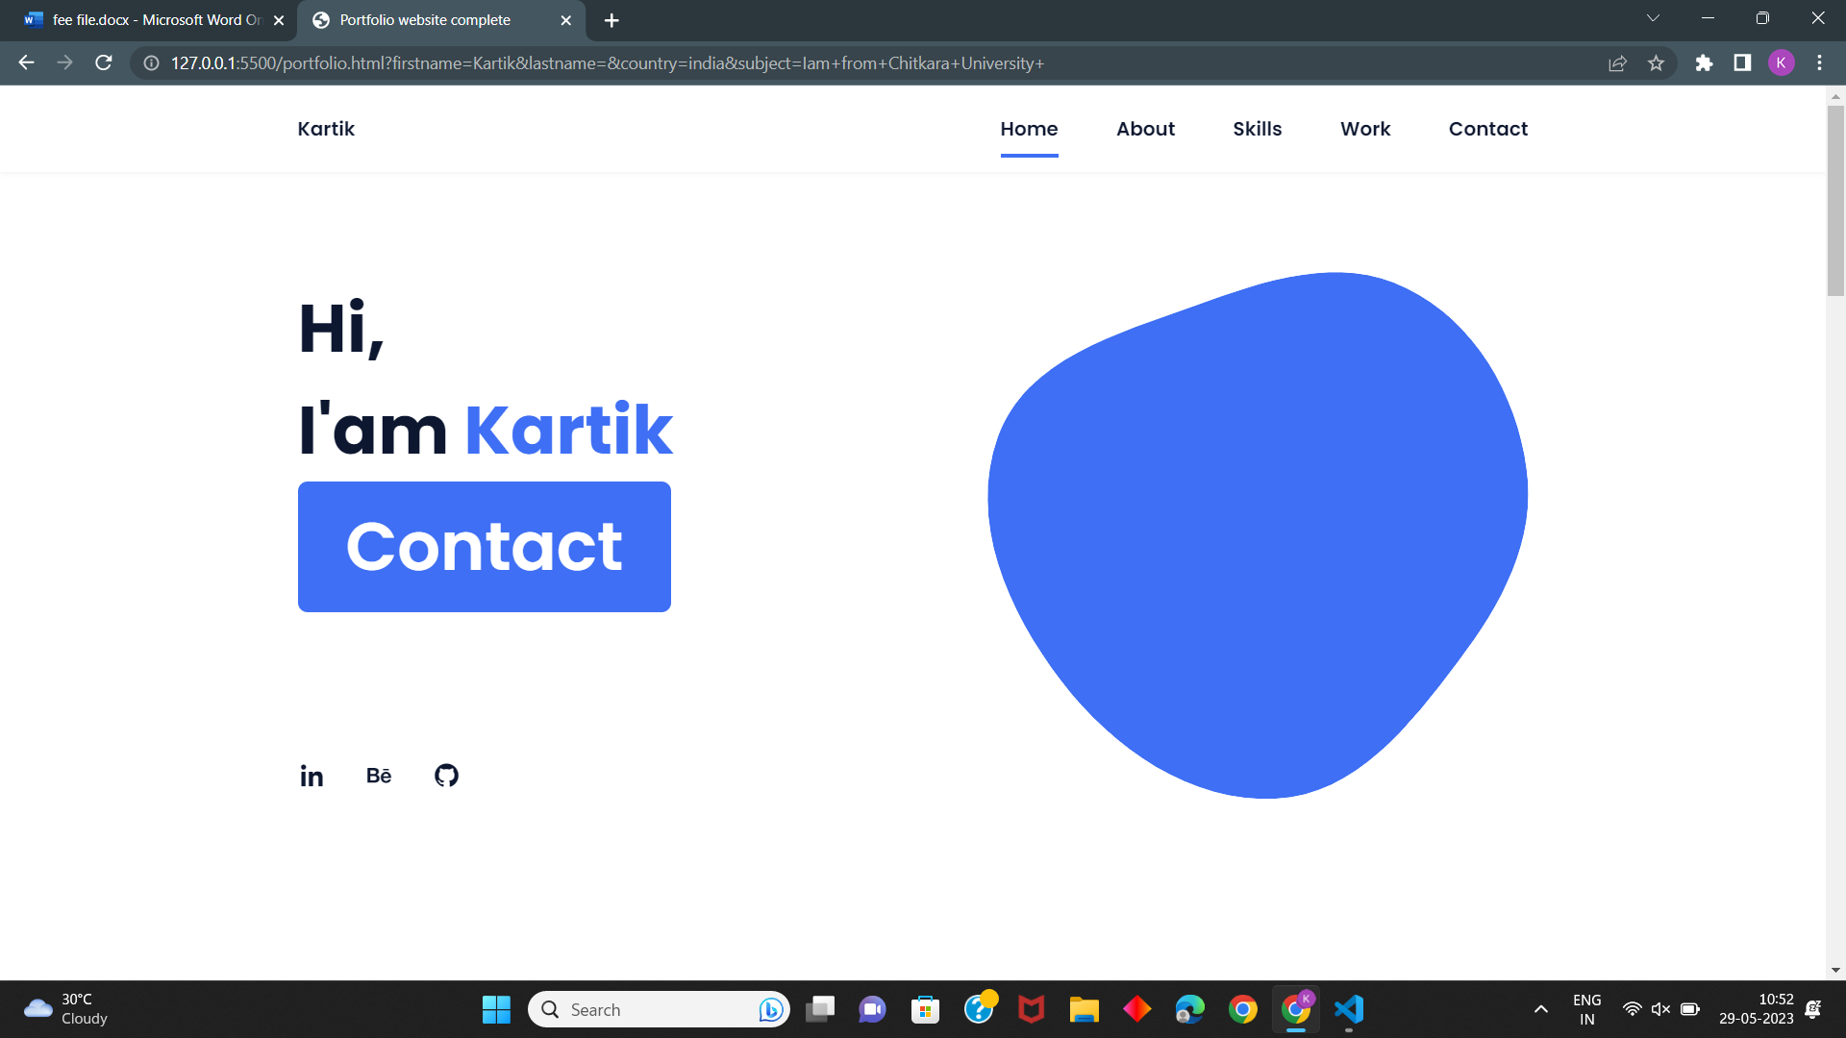

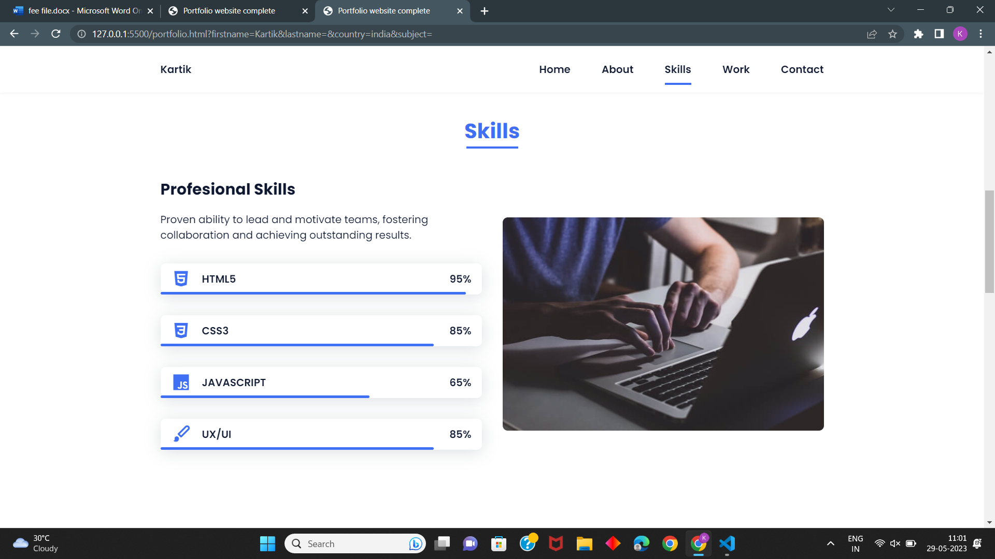

# Advantages

Enhanced Professional Branding: A portfolio website enables you to control your personal brand,

tailor your message, and create a unique visual identity that aligns with your professional goals.

Showcasing Your Best Work: You have the opportunity to curate and highlight your best projects,

achievements, and client testimonials, giving potential clients or employers a clear understanding of your

capabilities.

24/7 Accessibility: Unlike physical portfolios, a portfolio website is accessible at any time and from

anywhere, allowing you to reach a global audience and increasing your chances of getting noticed.

Improved User Experience: A well-designed and user-friendly portfolio website enhances the user experience,

making it easier for visitors to navigate through your work and find the information they need.

Data and Analytics: With various web analytics tools, you can track the performance of your portfolio

website, gaining insights into visitor behavior, popular content, and conversion rates.

**Visual Appeal**: Enables the creation of visually appealing portfolios that make a memorable impression on viewers.

**Time and Resource Efficiency**: Saves time and resources by providing pre-designed templates and intuitive

design tools.

**Professionalism**: Creates a cohesive and professional online presence for users.

**Social Media Integration**: Facilitates sharing portfolios across social media platforms to reach a wider audience.

**Analytics**: Provides insights into portfolio performance, allowing users to track engagement and make

informed improvements.

**Result**

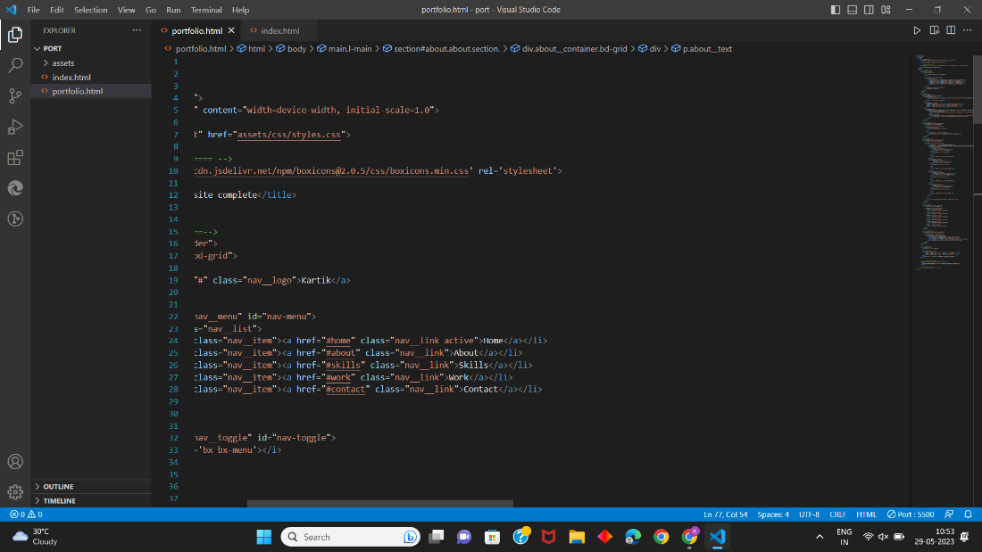

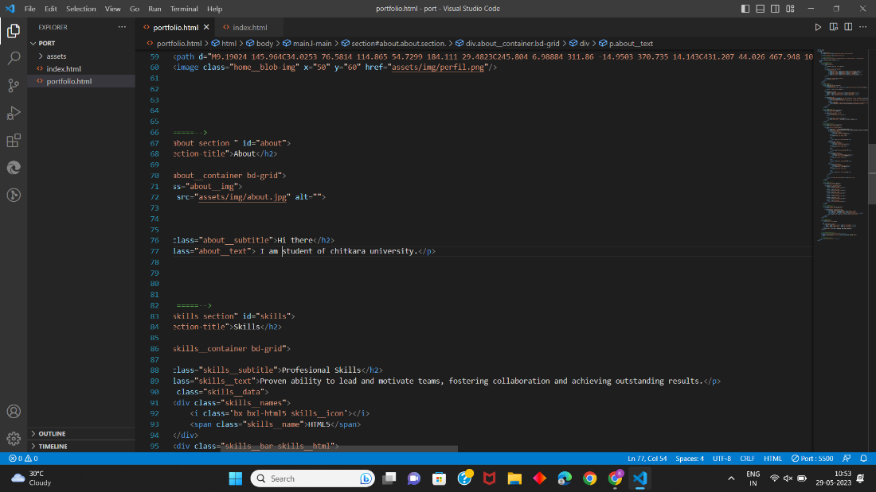

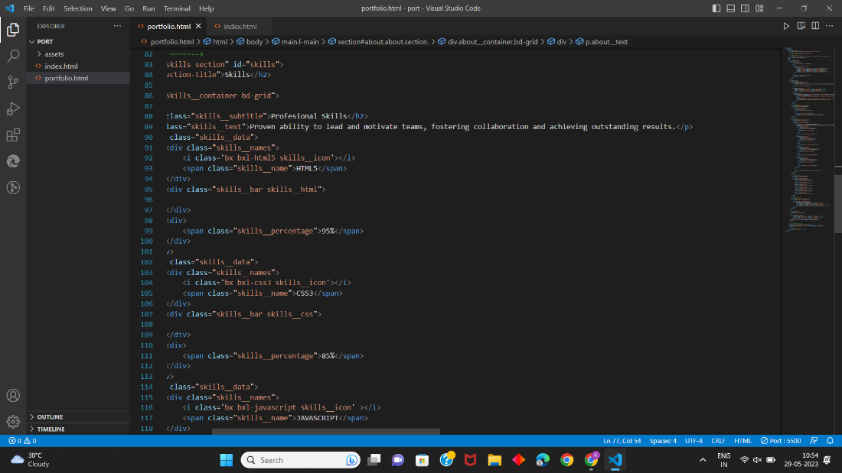

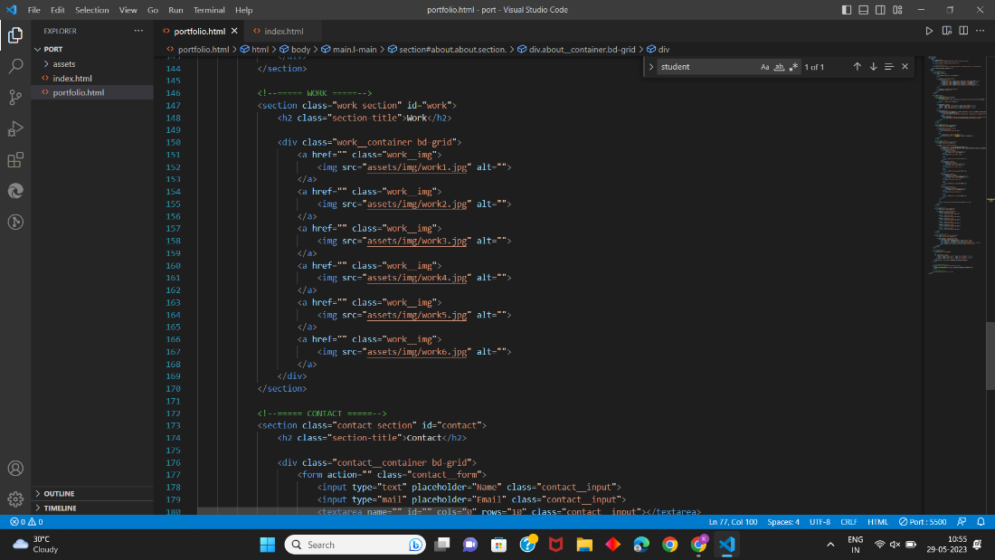

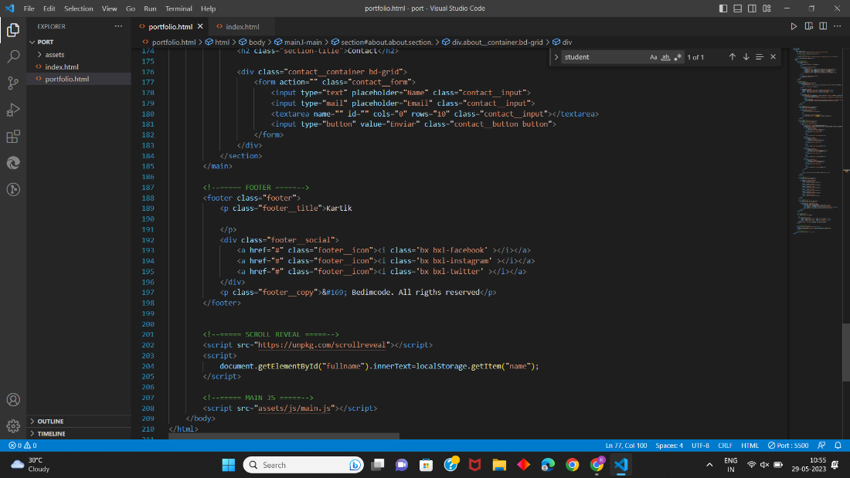

**Conclusion**

The To-Do List project presented above is a simple and effective way to manage daily tasks. It offers users an easy-to-use interface for adding tasks to a list, checking them off when completed, and removing them when no longer needed . Overall, the project demonstrates how HTML, CSS, and JavaScript can be combined to create a functional web application. By understanding the code and the logic behind it, developers can learn how to implement similar features into their own projects.

# Refs/link used:-

* [https://www.w3schools.com](https://copyassignment.com/to-do-list-in-html-css-javascript/)
* [https://copyassignment.com/to-do-list-in-html-css-javascript](https://copyassignment.com/to-do-list-in-html-css-javascript/)
* <https://developer.mozilla.org/en-US>